

Biotecnika Info Labs
Department of Bioinformatics, AI & Machine Learning

Integrated bioinformatics workflow for biomarker identification using microarray gene expression data

By
Arnab Koley

A report submitted in partial fulfilment of the summer internship program in Bioinformatics. Al and Machine Learning organised by Biotecnika

Supervised by
Dr. Nilofer Shaikh
ABSTRACT
Corona virus disease (SARS-COV19 or COVID-19) has emerged as a global respiratory disease with significant clinical similarities to other lung diseases that basically confined a link such as Chronic Obstructive Pulmonary Disease (COPD) and the existing bizarre “Pneumonia”. Coming across to understand these linked disorders, there are some potential biomarkers and therapeutic targets that is coming under some common molecular mechanisms. This present study is based to identify significant genes and potential biomarkers associated with COVID-19 and other mentioned lung disorders using integrated bioinformatics and machine learning. Gene expression datasets associated with covid-19, COPD and pneumonia were first obtained from the Gene expression omnibus (GEO) database. Differential gene expression analysis was performed using Python with selected criteria of Adjusted P value <0.05 and |logFC|<1. Machine learning regression models including XGboost, Random forest and gradient boosting were used to predict overlapping genes and gene expression notable patterns and prioritise hub genes. Protein – Protein interaction networks were constructed using STRING database and further analyzed using Cytoscape and Cytohubba. Followed up that functional enrichment analyses were performed using gene ontology (GO), KEGG, Reactome databases. The analysis identified several significant genes involved in immune regulation, antiviral defence and inflammatory responses. Cytokine – mediated signalling, chemokine activity and immune response pathways play critical role in disease progression. Hub genes including CXCL10, CXCL11, RSAD2, OASL, IFIT1, MX2 and HERC5 emerged as potential biomarkers. Overall, this study demonstrates integrating bioinformatics and machine learning approaches can be effective while identifying key molecular signatures associated with COVID-19 and related lung diseases.

Keywords: COVID-19, COPD, Pneumonia, Machine Learning, Biomarkers, Differential Gene expressions, Protein-Protein interaction, Pathway enrichment, Lung disorders

- WORKFLOW

- Collection of microarray gene expression datasets associated to COVID-19, COPD and Pneumonia from the NCBI-GEO database to study impacts, epidemiology of recent cases.
- COVID -19:- GSE212865, GSE164805, and GSE177477
- COPD :- GSE103174, GSE76925
- Pneumonia:- GSE48080, GSE133975, GSE47962
- Differential gene expression analysis was performed using Python on to identify genes expressed levels between diseased and healthy samples performed using
- Adjusted p value [p<0.05] and |logFC| threshold
After merging datasets there are total 262816 gene expressions observed of COVID and other selected lung diseases.
- Machine learning regression modeling of COVID-19 and other associated lung diseases for Gene Expression Prediction. Using
- Random forest {R² =0.8213}
- XGboost Regressor { R² =0.8242}
- Gradient Boosting Regressor {R² = 0.7811}
- Identification and Selection of Top 50 significant Genes by Absolute Predicted logFC using XGboost model to know their statistically significance (82%) are listed following tables below.
- Identification of overlapping genes between significant DEGs and predicted genes.
- After getting significant genes, PPI genes were subjected to Perform Protein–protein interaction (PPI) analysis using STRING to identify functional and physical interactions among proteins between COVID and associated lung diseases representing determined interactions, co-occurrence patterns, protein homology, and Co expression.
Where It was rather filtered based on gene regulations (up-regulated and Down regulated)
- Visualization and networking analysis of Protein- Protein Interaction data using Cytoscape and identification of hub genes using Cytohubba of selected most expressed genes resulting hub genes.
- The Functional genes were subjected to Gene Ontology(GO), molecular functions (MF), biological processes (BP) and cellular components (CC) and determining possible pathway enrichment analysis involved using KEGG, Reactome pathways to identify significantly enriched biological pathways and molecular mechanisms.
- Based on differential expression, PPI analysis, hub gene identification, and pathway enrichment analysis, potential biomarkers associated with COVID-19 and other related lung diseases.

2. INTRODUCTION
Corona virus disease 2019 (COVID -19) caused by severe acute respiratory syndrome corona virus 2 emerged as a global public health and has caused significant morbidity and mortality worldwide. Understanding it’s epidemiology it’s an Fnatic virus and spread rapidly across multiple continents and oceans, affecting millions of people worldwide simultaneously and based on this WHO (World health organization) declared it as “Pandemic” in 11th March, 2020. [2] As per research this disease primarily affects the respiratory system and can lead severe complications including Pneumonia, Acute respiratory distress syndrome (ARDS), and multi – organ failure (Huang et al.,2020). Although considerable progress has been made in understanding and underlying molecular mechanisms and interactions with other respiratory disorders remain incompletely understood [1] [2].
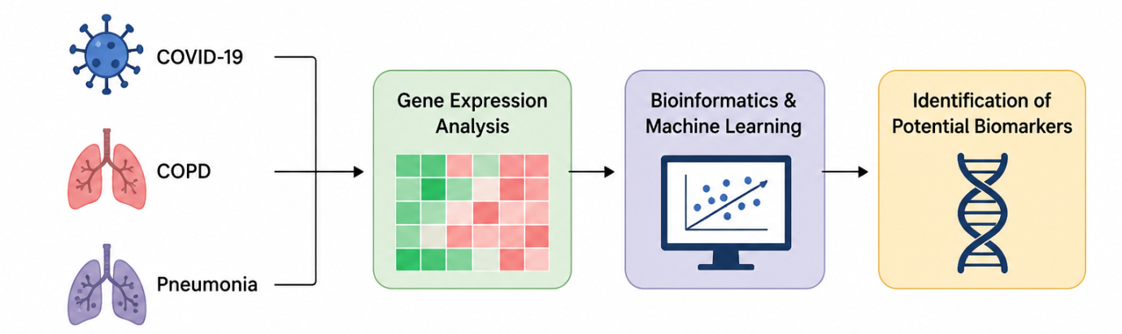
Figure 1: Overall Workflow of integrated bioinformatics and machine learning pipelines.

Chronic Obstructive Pulmonary Disease (COPD) and Pneumonia are among the most respiratory diseases worldwide. Numerous studies have implemented those patients with some notable pre existing respiratory disorders are at a higher risk of severe COVID – 19 outcomes, suggesting the presence of common pathological and molecular mechanisms among these diseases (Guan et al., 2020). [2][3] Inflammation, immune dysregulation, cytokine production, and Antiviral responses are important factors involved in the progression of these respiratory diseases. [3]
With modern technology and advancement in high throughput sequencing and publicly available transcriptomics databases such as the Gene Expression Omnibus (GEO) [https://www.ncbi.nlm.nih.gov/geo/ ] have wrapped with gene expression profiles. DEG or Differential gene expression is actually provide valuable and principal genetic informations significantly linked with disease conditions and to evaluate potential biomarkers (Edgar et al., 2002[4][5].
Comprehensive approaches with Machine learning is recently become essential for its analysis of large scale biological datasets and capturing hidden patterns associated with disorders [3][4][5]. Algorithms e.g. Random forest, XGboost & gradient boosting have shown prominent performance in gene selection and disease prediction studies (Chen and Guestrin 2016) [4].
Apparently, protein–protein interaction (PPI) network scrutiny and functional enrichment analyses such as Gene Ontology (GO), Kyoto Encyclopaedia of Genes and Genomes (KEGG), and Reactome illuminate the biological functions and signalling pathways connected with disease-related genes (Szklarczyk et al., 2019) [7] Consequently, the present study employed an integrated bioinformatics and machine learning loom to inspect the common molecular signatures among COVID-19, COPD, and Pneumonia. Differential gene expression analysis, machine learning prediction, protein–protein interaction analysis, hub gene identification, and pathway enrichment analyses were performed to identify potential biomarkers and recognize the molecular mechanisms underlying these respiratory diseases.[5] The findings of this study may chip in to the identification of novel diagnostic biomarkers and therapeutic targets and provide valuable insights into the united molecular mechanisms of COVID-19 and linked lung diseases [6] [7].

3. MATERIALS AND METHOD:
This present study employed an incorporated bioinformatics and machine learning move towards to investigate common molecular signatures between COVID-19 and associated respiratory diseases, including chronic obstructive pulmonary disease (COPD) and Pneumonia.[2] The overall workflow consisted of dataset collection, Differential gene expression analysis, Machine learning based gene prediction, protein – protein interaction network construction, hub gene identification and functional enrichment analysis.[1][3]
3.1 DATASET COLLECTION
Gene expression datasets associated with COVID – 19, COPD and Pneumonia were pulled out from the NCBI GEO database that is publicly repository for high throughput gene expression data (Edgar et al., 2002) includes[2][3]
DATASETS | DISEASES
GSE212865, GSE164805, GSE177477 | COVID-19
GSE103174, GSE76925 | COPD
GSE48080, GSE133975, GSE47962 | PNEUMONIA
Table 1: Pulled out datasets from NCBI-GEO of COVID, COPD, Pneumonia

3.3. DIFFERENTIAL GENE EXPRESSION ANALYSIS
Differential gene expression analysis was performed using Python programming language (Google colab) to identify genes exhibiting significant and prominent expressions change between diseased and control samples of each diseases. The statistical filter criteria included

- Adjusted P value < 0.05
- Absolute Log fold change (logFC)>1
Genes those are satisfied these both condition were subjected statistically significant for further analysis (Ritchie et al., 2015). [8]
3.4 MACHINE LEARNING REGRESSION ANALYSIS
Perhaps, Machine learning regression analysis was employed to predict gene expression patterns and prioritize important genes associated with respiratory diseases. To identify important genes basically Random Forest Regressor, XGBoost and Regressor Gradient Boosting Regressor was evaluated using the co-efficient of determination R² score. (Chen and Guestrin, 2016). [4][5]
3.5 PROTEIN–PROTEIN INTERACTION & NETWORK CONSTRUCTION
Significant genes identified from the machine learning analysis furthermore transferred to the STRING database to examine functional and physical interactions among proteins. It integrates known and predicted protein interactions obtained from experimental studies, co-expression data, databases, and computational predictions (Szklarczyk et al., 2019). [7]
3.6 NETWORK VISUALIZATION AND HUB GENE IDENTIFICATION
The protein interaction network generated by STRING was imported into Cytoscape software for visualization and networking (Shannon et al., 2003). Hub genes were identified using the Cytohubba based on the Maximal Clique Centrality (MCC) algorithm, which ranks genes according to their topological importance within the network (Chin et al., 2014). [5]
3.7 FUNCTIONAL ENRICHMENT ANALYSIS
After getting hub genes it was performed using EnrichR to identify enriched biological functions and pathways associated with the selected genes (Kuleshov et al., 2016). Databases named Gene Ontology (GO), Biological Process (BP) Molecular Function (MF), Cellular Component (CC), Kyoto Encyclopaedia of Genes and Genomes (KEGG), Reactome Pathway, Database were used and performed to understand the biological significance and molecular pathways involved in disease progression.[6][8][9]
4. RESULTS:
4.1 Differentially expressed genes DEG Identification.
COPD:
This volcano plot identified significantly differentially expressed genes using the criteria of adjusted P-value < 0.05 and |logFC| > 1. Both upregulated (red) and down regulated (blue) genes were observed, indicating substantial transcriptional changes between the study groups, while the remaining genes were classified as non-significant (gray). These DEGs were afterwards used for protein–protein interaction, functional enrichment, and machine learning analyses for Covid, COPD and Pneumonia.
For COPD, the volcano plot is illustrating the differential gene expression. The x-axis represents the log₂ fold change (logFC), while the y-axis represents the −log₁₀ adjusted p-value, reflecting the statistical significance of gene expression changes. Using the thresholds of adjusted p-value < 0.05 and |log₂FC| ≥ 1, a total of 66 differentially expressed genes (DEGs) were acknowledged, comprising 34 upregulated and 32 down regulated genes. The admired of genes were clustered around log₂FC = 0 and exhibited low statistical implication, indicating that most genes were not differentially expressed under the selected criterion, with several upregulated genes displaying high fold-change values and strong statistical significance (−log₁₀ adjusted p-value > 10), suggesting robust activation in COPD samples. Down regulated genes were rather fewer and exhibited lower statistical significance than the upregulated genes.
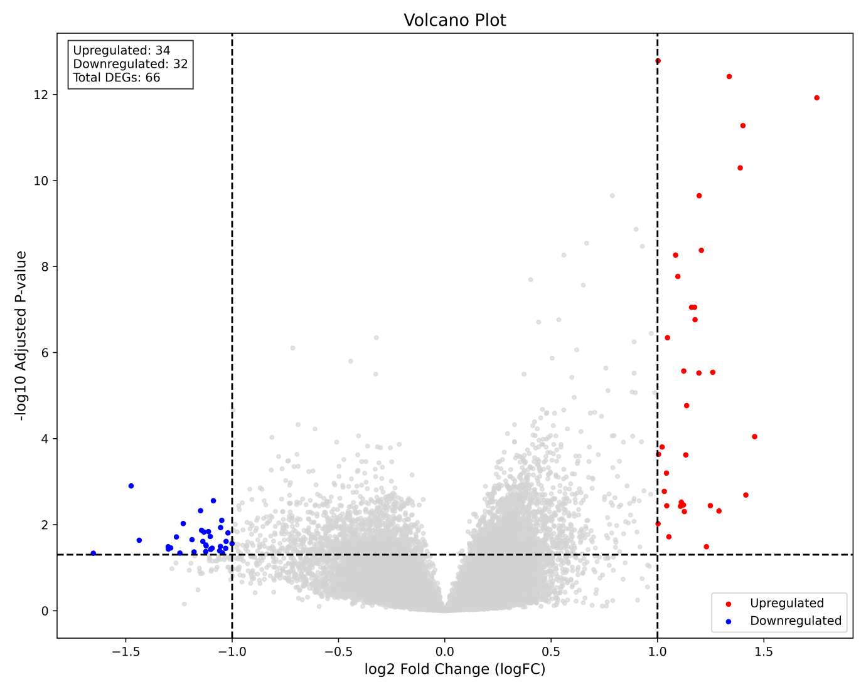
Figure: 3. Interpretation of volcano plot of COPD disease of differential gene expression with the criteria (Logfc >- 1 and Adj P value <0.05

COVID:
In This volcano plot is showing the differential gene expression profile for COVID-19. X-axis represents the log₂ fold change (logFC), while the y-axis represents the −log₁₀ adjusted p-value, demonstrating the statistical significance of differential gene expression. Based on the thresholds of adjusted p-value < 0.05 and |log₂FC| ≥ 1, a total of 5,178 differentially expressed genes (DEGs) were identified, including 2,781 upregulated and 2,397 down regulated genes. The majority of genes were clustered around log₂FC = 0 and exhibited low statistical significance, indicating minimal or no differential expression, whereas a substantial number of genes exceeded both the fold-change and statistical significance thresholds. Several genes exhibited high fold-change values together with strong statistical implication, showing robust transcriptional alterations associated with SARS-CoV-2 infection.
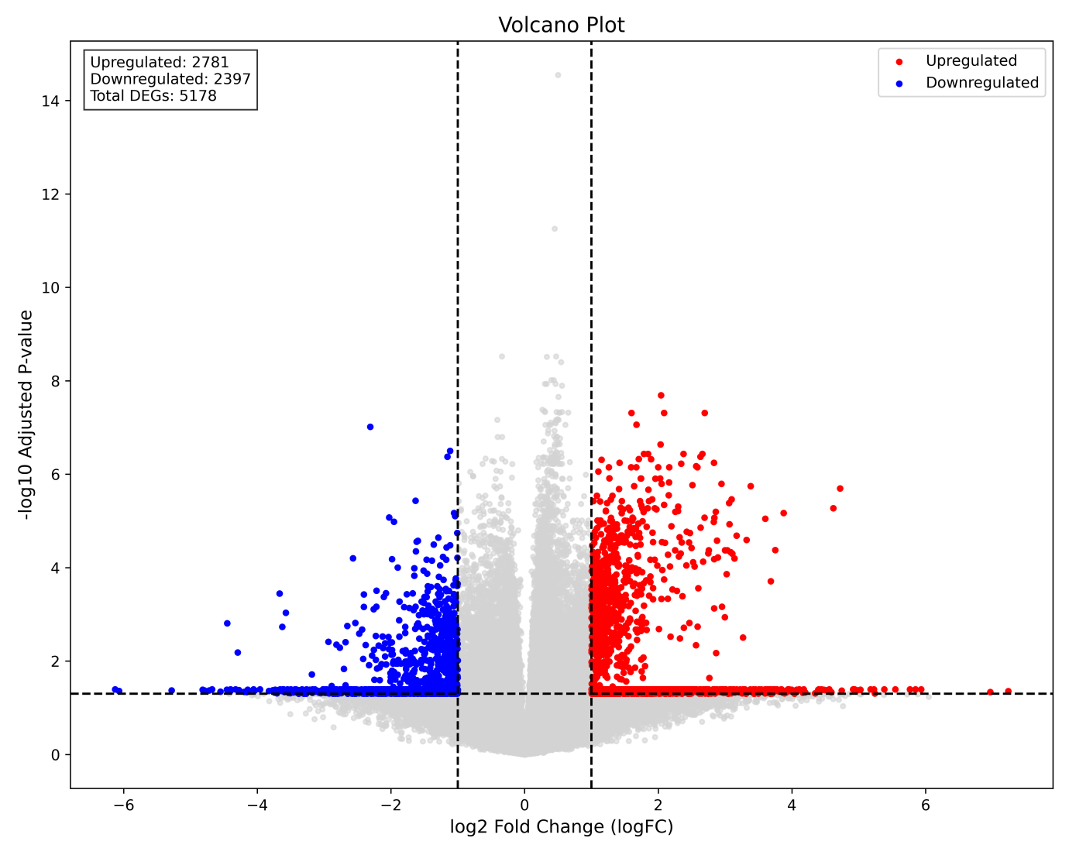
Figure: 4. Interpretation of volcano plot of COVID and implementation of differential gene expression of expressed genes

PNEUMONIA:
It illustrates the differential gene expression profile of pneumonia using the selected thresholds of |log₂FC| ≥ 1 and adjusted p-value < 0.05. A total of 105 differentially expressed genes (DEGs) were identified, comprising 31 upregulated genes and 74 down regulated genes, indicating that gene down regulation predominated in pneumonia. The majority of genes are clustered around the centre of the plot and below the significance threshold, In contrast, the significant DEGs are distributed on both sides of the plot, with down regulated genes (blue) being more numerous and extending to larger negative log₂ fold-change values than the upregulated genes (red).
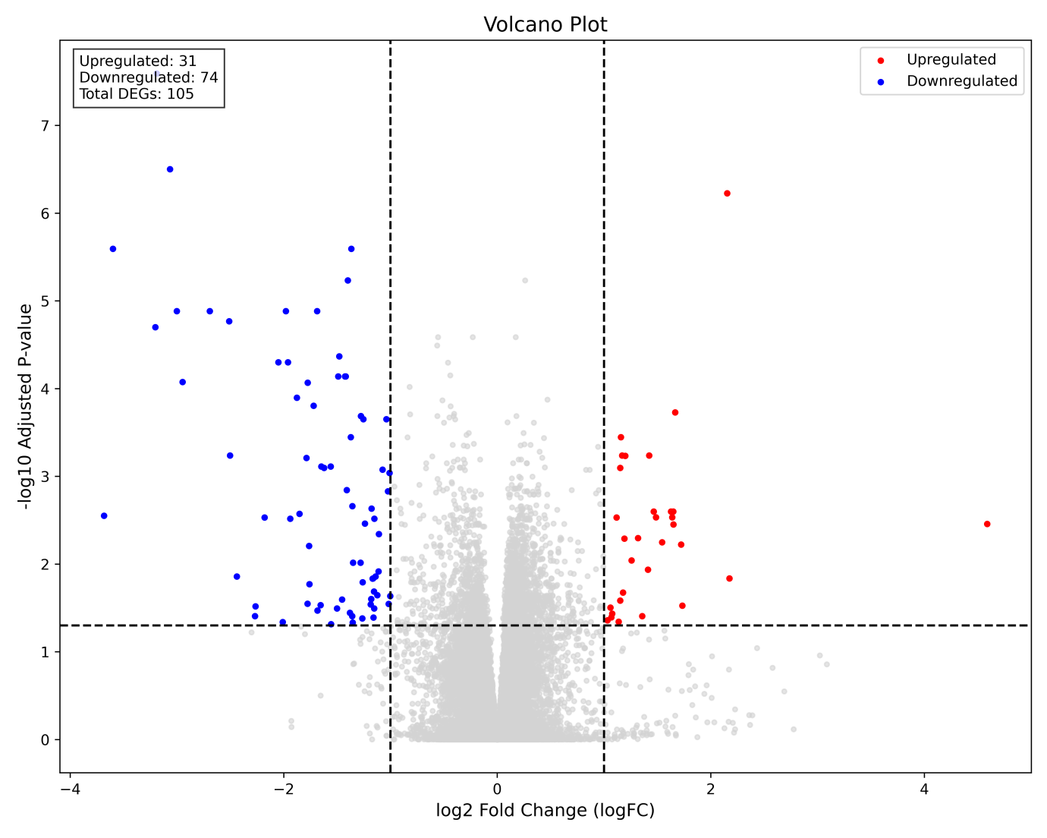
Figure: 5. volcano plot of Pneumonia datasets and implementation of differential gene expression of expressed genes

4.2 Machine Learning Regression analysis:
The scatter plot showing below a strong correlation between the actual and predicted values, with most data points distributed close to the ideal prediction line. Among the models, XGBoost Regressor showed the highest predictive performance (R² = 0.8242), followed by Random Forest (R² = 0.8213) and Gradient Boosting Regressor (R² = 0.7811). It indicates models effectively captured gene expression patterns and enabled the identification of significant genes for subsequent analyses.
Total genes: 262815:
Total DEGs: 5349:
Up regulated: 2846;
Down regulated: 2503
Genes used for ML: 5349

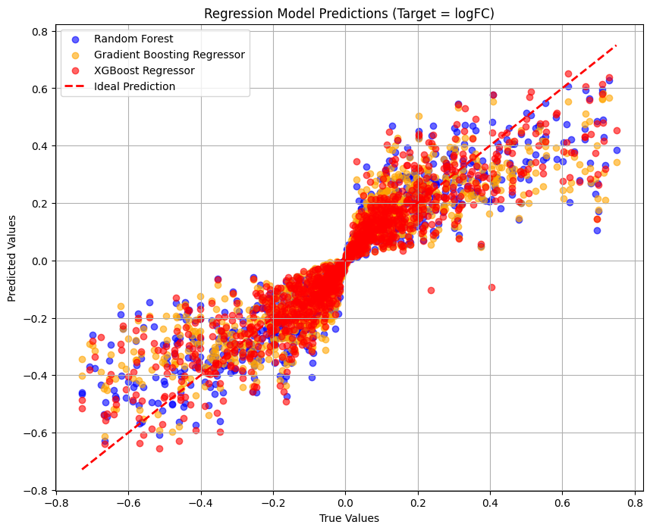
Figure: 6 Performance comparisons of Random Forest, XGBoost, and Gradient Boosting regression models for predicting logFC values.
Gene Symbol | logfc | Adjusted P-value
CXCL10 | -2.439 | 0.01388
CXCL11 | -2.009 | 0.04596
OASL | -1.777 | 0.02829
APOBEC3A | -1.683 | 0.03391
RSAD2 | -1.655 | 0.02946
C20orf114 | -1.653 | 0.04603
IFIT1 | -1.501 | 0.03208
LOC402057* | 1.457 | 0.00009
IFI44L | -1.454 | 0.02538
LOC100132394* | 1.415 | 0.00205
LOC401717* | 1.402 | 5.31E-12
FOS | -1.399 | 5.85E-06
MX2 | -1.358 | 0.03918
CD83 | -1.358 | 0.00219
LOC645693* | 1.337 | 3.81E-13
LOC100008589* | 1.289 | 0.00482
NR4A1 | -1.278 | 0.00021
C11orf96 | -1.261 | 0.01612
LOC390735* | 1.248 | 0.00362
FOSB | -1.239 | 0.00345
LOC100133773* | 1.206 | 4.19E-09
LOC441032* | 1.196 | 2.26E-10
LOC648659* | 1.195 | 2.99E-06
PTX3* | -1.180 | 0.02500
DNHD2 | -1.179 | 0.04294
COMP* | 1.178 | 0.02110
LOC400652* | 1.177 | 1.71E-07
LOC390183* | 1.175 | 8.84E-08
EGR4 | -1.163 | 0.01456
LOC649150* | 1.160 | 8.84E-08
HERC5 | -1.159 | 0.04076
ACHE | -1.154 | 0.02062
CXCL9 | -1.153 | 0.03208
CDH29 | -1.138 | 0.02453
LOC100127893* | 1.137 | 1.71E-05
LOC100133329* | 1.133 | 0.00024
LOC646949* | 1.123 | 2.68E-06
FCGR3B | 1.112 | 0.00300
CXCL2 | -1.109 | 0.00456
LOC649839* | 1.108 | 0.00372
LOC649873* | 1.095 | 1.70E-08
Table 2: List of Statistically Significant Genes using Machine learning approach

4.3 PROTEIN–PROTEIN INTERACTION NETWORK ANALYSIS
The top 50 genes identified by the machine learning models were evaluated and statistically significant genes were selected based on their biological function and relevance to diseases after STRING (PPI) analysis listed below. To investigate the functional relationships among the selected genes got after machine learning regression, as results network showing strong interactions among several immune and antiviral related genes, formed a dense interaction cluster, indicating their involvement in common or overlapping biological pathways. Several genes associated with interferon signalling, inflammatory responses, and chemokine-mediated immune regulation exhibited extensive connectivity, whereas a few genes showed limited interactions diseases.
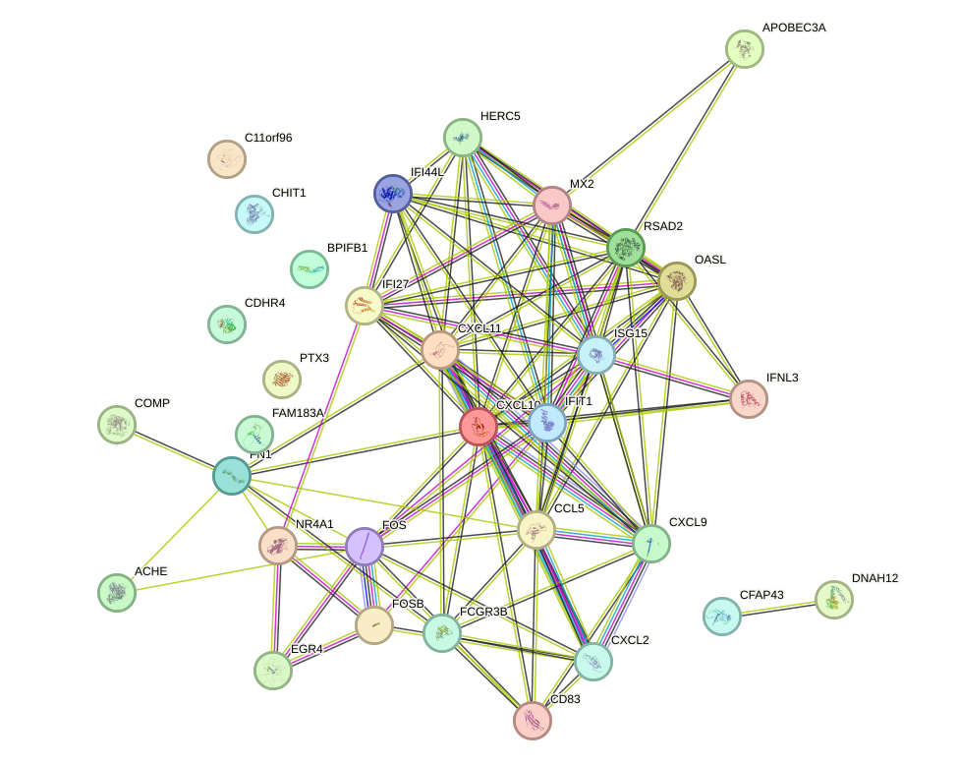
Figure: 7 Protein -Protein interaction of top 50 genes of COVID -19 and related respiratory diseases

Figure: 4 Protein - protein interaction network analysis using STRING

4.5 NETWORK VISUALIZATION AND HUB GENE IDENTIFICATION
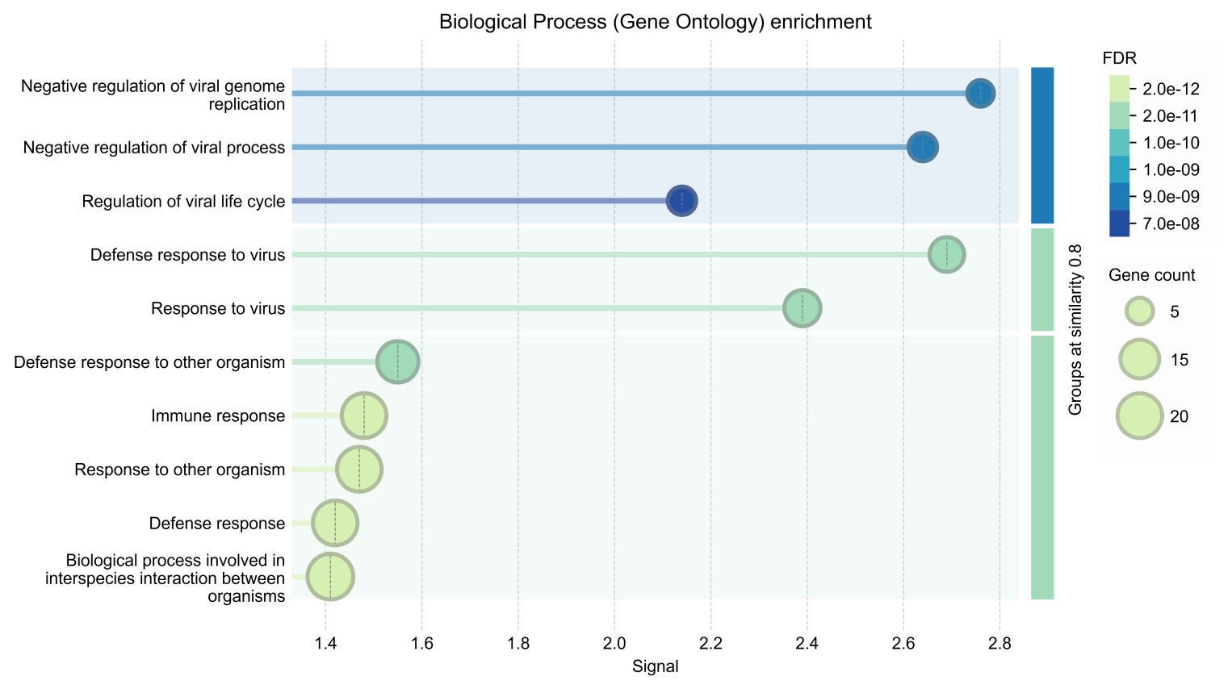
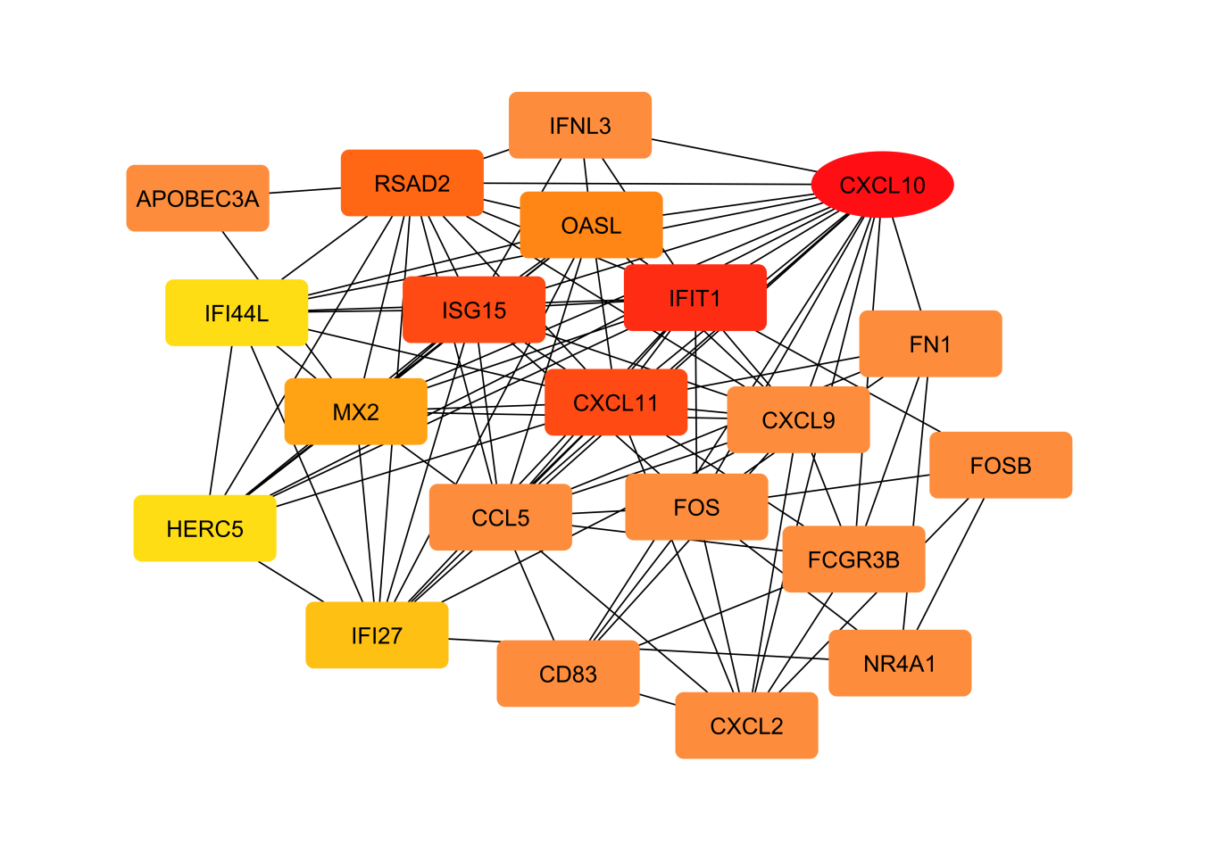
Selected 21 genes were identified several highly connected hub genes involved in immune regulation, antiviral defence, and inflammatory responses further putted in Cytoscape to visualize networking of Genes such as CXCL10, IFIT1, ISG15, CXCL11, RSAD2, OASL, and MX2 occupied central positions within the network, indicating their potential roles in disease progression. These genes are mainly associated with interferon signalling, cytokine activity, and host immune responses,
Figure: 8 Cytoscape analysis of selected 21 hub genes and biological process (GENE ONTOLOGY) analysis
4.6 Overlapping Gene Analysis
From 21 hub genes, 16 Overlapping genes identified and were considered important candidate genes because of their statistical significance and network centrality.
Sl. No. | Gene Symbol | logFC | Adjusted P-value | Regulation | Biological Function
1 | APOBEC3A | -1.683 | 0.03391 | Down | Antiviral defense
2 | RSAD2 | -1.655 | 0.02946 | Down | Interferon-mediated antiviral response
3 | OASL | -1.777 | 0.02829 | Down | Innate immune response
4 | CXCL10 | -2.439 | 0.01388 | Down | Chemokine signaling
5 | IFI44L | -1.454 | 0.02538 | Down | Interferon response
6 | IFIT1 | -1.501 | 0.03208 | Down | Antiviral activity
7 | MX2 | -1.358 | 0.03918 | Down | Viral inhibition
8 | CXCL11 | -2.009 | 0.04596 | Down | Immune cell recruitment
9 | CXCL9 | -1.153 | 0.03208 | Down | Inflammatory response
10 | FOSB | -1.239 | 0.00345 | Down | Transcription regulation
11 | HERC5 | -1.159 | 0.04076 | Down | Interferon signaling
12 | FOS | -1.399 | 0.000006 | Down | Cellular stress response
13 | FCGR3B | 1.112 | 0.00300 | Up | Neutrophil activation
14 | CD83 | -1.358 | 0.00219 | Down | Immune activation
15 | NR4A1 | -1.278 | 0.00021 | Down | Inflammatory regulation
16 | CXCL2 | -1.109 | 0.00456 | Down | Chemokine signaling
Table 4: List of overlapping genes after machine learning regression approaches.

4.7 PATHWAY ENRICHMENT ANALYSIS
As result, Enrichment analysis revealed that the selected genes were mainly involved in immune and antiviral responses. GO analysis showed enrichment in defense response to virus and regulation of viral processes, while KEGG pathways highlighted IL-17 signaling, Toll-like receptor signaling, cytokine-cytokine receptor interaction, and chemokine signaling pathways. Reactome analysis further demonstrated significant enrichment in cytokine signaling,
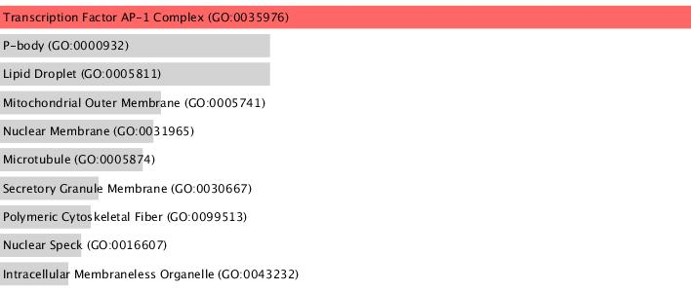
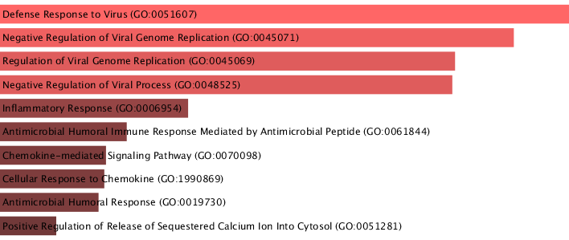
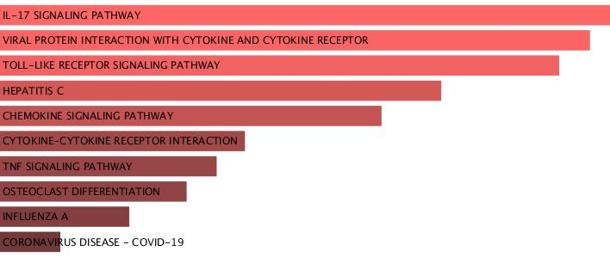
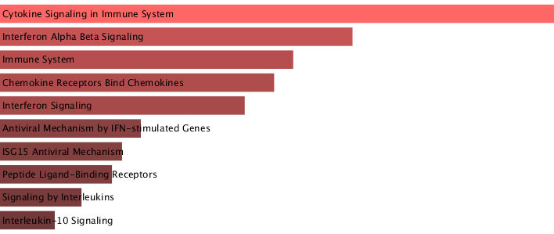
Figure: 9) Reactome Pathway analysis b) KEGG analysis c) GO, cellular component and molecular function enrichment analysis.
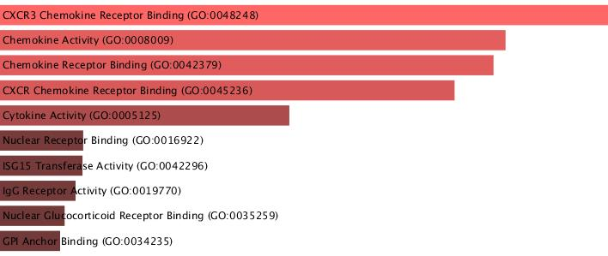
4.8 POTENTIAL BIOMARKERS OBSERVATION
The key genes were observed as BIOMARKERS based on their biological significance, relevance and central role in interaction network and diseases regulations and major functions are listed below.
Biomarker | Major Function | Associated Pathway
CXCL10 | Chemokine signaling | Cytokine signaling
CXCL11 | Immune recruitment | Chemokine signaling
RSAD2 | Antiviral defense | Interferon signaling
OASL | Innate immunity | Interferon signaling
IFIT1 | Viral inhibition | Antiviral pathway
IFI44L | Immune regulation | Interferon pathway
MX2 | Viral restriction | Interferon pathway
CXCL9 | Inflammatory response | Chemokine pathway
HERC5 | Protein ISGylation | Antiviral pathway
CD83 | Immune activation | Adaptive immunity
Table 5: Potential biomarkers

DISCUSSION
During this study it is identification about several immune and antiviral-related genes associated with COVID-19 and other respiratory diseases using bioinformatics and machine learning approaches. Functional enrichment analyses indicated that these genes are mainly involved in interferon signalling, cytokine signalling, and antiviral defense pathways that regulates the disease. The identified genes may play important roles in disease progression and could serve as possible biomarkers. However, further experimental justification is necessary to verify these results.
CONCLUSION
It is employed an integrated bioinformatics and machine learning approach to identify significant genes and molecular pathways associated with COVID-19 and related respiratory diseases. Network and enrichment analyses revealed that the identified genes are primarily involved in immune regulation, different regulated signalling like interferon signalling, cytokine signalling, and antiviral responses. Several hub genes were identified as potential biomarkers due to their significant expression patterns and biological relevance. Overall, the study demonstrates that combining bioinformatics analyses with machine learning techniques can effectively identify candidate biomarkers and provide insights into the molecular mechanisms underlying respiratory diseases.
REFERENCE
- Edgar R, Domrachev M, Lash AE. Gene Expression Omnibus: NCBI gene expression and hybridization array data repository. Nucleic Acids Research. 2002;30(1):207–210.
- Huang C, Wang Y, Li X, et al. Clinical features of patients infected with 2019 novel corona virus in Wuhan, China. The Lancet. 2020;395(10223):497–506.
- Guan WJ, Ni ZY, Hu Y, et al. Clinical characteristics of coronavirus disease 2019 in China. New England Journal of Medicine. 2020;382(18):1708–1720.
- Chen T, Guestrin C. XGBoost: A scalable tree boosting system. In: Proceedings of the 22nd ACM SIGKDD International Conference on Knowledge Discovery and Data Mining. 2016.
- Breiman L. Random Forests. Machine Learning. 2001;45(1):5–32.
- Friedman JH. Greedy function approximation: A gradient boosting machine. Annals of Statistics. 2001;29(5):1189–1232.
- Szklarczyk D, Gable AL, Lyon D, et al. STRING v11: protein–protein association networks with increased coverage. Nucleic Acids Research. 2019;47(D1):D607–D613.
- Ritchie ME, Phipson B, Wu D, Hu Y, Law CW, Shi W, Smyth GK. limma powers differential expression analyses for RNA-sequencing and microarray studies. Nucleic Acids Res. 2015 Apr 20;43(7):e47. doi: 10.1093/nar/gkv007. Epub 2015 Jan 20. PMID: 25605792; PMCID: PMC4402510.
- Shannon P, Markiel A, Ozier O, et al. Cytoscape: A software environment for integrated models of biomolecular interaction networks. Genome Research. 2003;13(11):2498–2504.
- Chin CH, Chen SH, Wu HH, et al. CytoHubba: identifying hub objects and subnetworks from complex interactomes. BMC Systems Biology. 2014;8(Suppl 4):S11.
- Kuleshov MV, Jones MR, Rouillard AD, et al. Enrichr: a comprehensive gene set enrichment analysis web server. Nucleic Acids Research. 2016;44(W1):W90–W97.
- Kanehisa M, Goto S. KEGG: Kyoto Encyclopedia of Genes and Genomes. Nucleic Acids Research. 2000;28(1):27–30.
- Jassal B, Matthews L, Viteri G, et al. The Reactome pathway knowledgebase. Nucleic Acids Research. 2020;48(D1):D498–D503.
- Ashburner M, Ball CA, Blake JA, et al. Gene Ontology: tool for the unification of biology. Nature Genetics. 2000; 25(1):25–29.

